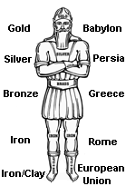
Daniel 2:24-49

2:24
Daniel is concerned about the wise men of Babylon

2:25
Arioch takes credit with having found Daniel. He must be confident
that Daniel will not disappoint Nebuchadnezzar.
Is he surprised that he found someone among the exiles of Judah?

2:26
2:27
No man can know these things, but there is a God who will reveal them.

2:28
“In Days to Come” literally "in the latter part of the days"
- This phrase first appears in Genesis 49:1. And then is also found in Numbers 24:14; Deut. 4:30; Deut. 31:29; Isaiah 2:2; Micah 4:1; Jeremiah 23:20; 30:24; 48:47; 49:39; Ezekiel 38:16; Daniel 10:14; Hosea 3:5
- It always refers to the future
- The context determines how far into the future it reaches
- Usually it is associated with the Messiah
- Parallel NT phrase "in the last days" - Acts 2:17; 2 Timothy 3:1; Hebrews 1:2; James 5:3; 2 Peter 3:3
This vision will cover the history of man from 600 BC until the second coming of Christ

2:29
As Nebuchadnezzar was going to sleep he began to wonder about the future. Possibly about
the destiny of the world. God responded to Nebuchadnezzar’s thoughts with an answer in the form of a dream.
Notice: Daniel even knew what Nebuchadnezzar was thinking about before he went to sleep the
night of the dream.

2:30
The interpretation was given for understanding

2:31
"Enormous" - later Nebuchadnezzar would build a 90 foot statue possibly to duplicate this one
"Dazzling statue" - reflecting light from the gold, silver and bronze
"Awesome in appearance" - root word for awesome is "dehal which means "to fear". This statue frightened Nebuchadnezzar as looked at the huge image towering over him

Interpretation of Nebuchadnezzar’s Vision of a Statue
 | Material | Value  in US $ | Hard-  ness | Specific  Gravity | Empire | First  Year | Initiating  Event
Head | Gold | $870/ ounce | Softest | 19 | Babylon | 605 BC | Nebuchadnezzar Defeats Assyria and enters Jerusalem
Chest | Silver | $16/ ounce | Soft | 11 | Persia | 539 BC | Cyrus and Darius take Babylon; the Jews are sent back to Jerusalem
Waist | Bronze | $1.45/ ounce | Hard | 8.5 | Greek | 331 BC | Alexander enter Jerusalem in 332 BC and took Babylon in 331
Legs | Iron | Pennies | Hardest | 7.8 | Rome | 63BC | Pompey takes Jerusalem and enters the  Holy of Holies
Feet | Iron/Clay | Worthless | Brittle | Clay is 2 | (future) | future | Seven year treaty  signed with Israel
- The head is the only part made of only one metal. The torso is sliver and bronze. The legs and feet are iron and clay.
- The value of the substances decrease
- The specific gravity of the material indicates the image is top heavy
- The material in the image begins soft and become hard and brittle.
- The feet are the most unstable.
- The clay may have been baked clay like the Babylonians used for their tile
- The Greek Hesiod used gold, silver, bronze and iron to represent periods of human history around 800 BC and the Roman poet Ovid uses the same four metals to represent the four ages of humans.
- The feet are worthless:
  - in value
  - for molding or shaping
  - to serve as a base or support
- The head is:
  - Very valuable since it is gold
  - Very pliable and shapeable
  - Very heavy and stable

2:34
Even more frightful than the awesome statue was the rock that destroyed it!
- The Rock was not a human empire. It was supernatural
- The Rock power unknown to the other empires who had simply replaced the previous empire. The rock destroyed and vaporized all of the remains of the other empires.
- The kingdom of the Rock was worldwide

2:35

2:36
Daniels distinguishes the dream itself from the interpretation for clarity
“We” is an pronoun of humility and also forces Nebuchadnezzar to remember God is behind this

2:37
- Jeremiah 27:6-7, 14 - Jeremiah warned Edom, Moab, Ammon, Tyre, Sidon and Judah that God had given Nebuchadnezzar sovereignty over the entire earth including the birds and animals
- Ezekiel 26:7 – Nebuchadnezzar is called the “king of kings”
Nebuchadnezzar’s very words were law. Any law could be overruled by Nebuchadnezzar.
Later the Persian rulers were limited by previous laws of the land. The Medo-Persian
monarchs could not annul a law once it went into effect (see Daniel 6:8, 12). And, the Greeks were developing a sense of democracy. The Romans had a senate to represent the people. But, in Babylon there was no law limiting the emperor, no sense of democracy and there was no representatives for the people like the Roman senate.

The sovereign God had given Nebuchadnezar:
- dominion – the head
- power – the weight of the head
- might –
- glory – the value as gold

Nabopolassar founded the Babylonian empire in 627 BC and it fell in 539 BC. It endured 88 years. Nebuchadnezzar ruled for 45 years (605-560)
2:38

2:39
Persia was inferior concerning the ruler’s authority but superior in size and length (208 years
from 539-331 BC)
The two arms may represent the united kingdom of the Medes and the Persians as the Medo-
Persian Empire.

Scholars who believe (wrongly) that the book of Daniel was written during the days of the
Maccabees identify the four empires as Babylon, Medes, Persia and then the Greeks
(Seleucid). But, the Medes never had world power but with the Persians and the writer
(Daniel) associates them as the same empire in 8:20 as the two horned ram.
2:40
Greece controlled much more than Persia from 331-31 BC for a total of 200 years. Although Alexander’s empire split into four sections after his death. It was not unified as Babylon and Persia. The republican form of government limited the Greek rulers and kings.

Rome ruled from 31 BC until 476 in the West. Then the capital was moved East to Constantinople which stood until the Muslim overran it in 1453. At its peak Rome ruled the greatest territory from the British Isle, Europe, Spain, the Middle East, North Africa all the way into India. There was clearly Western Roman world and an Eastern Roman world. These distinction still exist today

Rome is described with four terms:
- strong
- breaks
- smashes
- crush

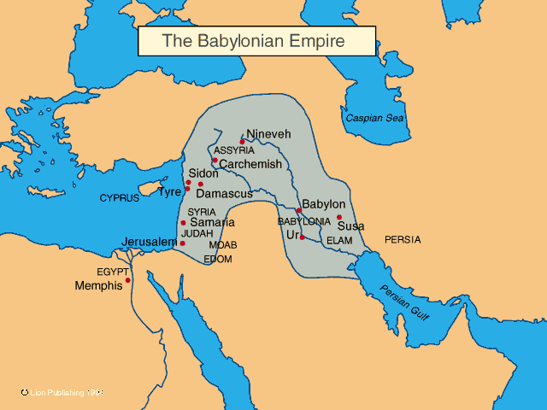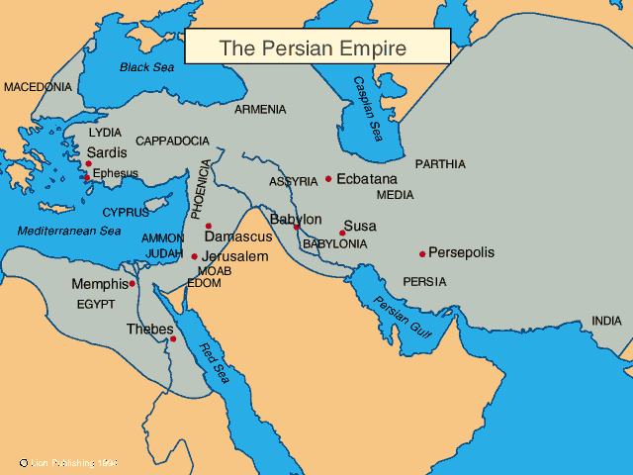

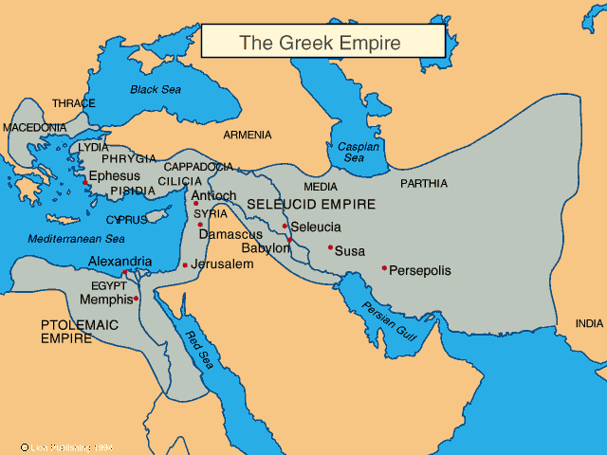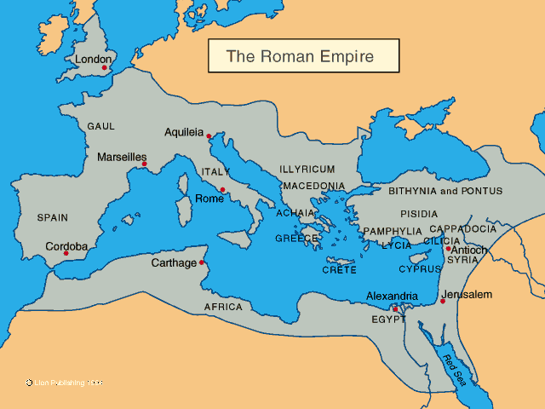

2:41
This fifth phase of the statue gets much more attention:
- This fifth phase, the feet, is not called a fifth kingdom. Instead it appears to be the final form of the fourth kingdom. The iron of Rome simply runs into the clay of the earth at the statues feet and is weakened.
- The feet are mixed clay and iron. This could represent:
  - Imperial Roman rule mixed with democracy (rule of the people, the clay, the mob, the special interest groups). Imperial rule and democracy do not mix. (Remember Laodicea “lao” = people, “dicea” = rule)
- The iron mixed with clay may indicate a mixture of any of these things that will not allow this form of the kingdom to endure. (An attempt to undue the effects of Babel):
  - Races
  - Political ideologies
  - Special Interests
  - Cultures
  - Language
- The result of the iron/clay:
  - Disunity
  - Class struggle
  - Civil war
  - Failed one world order

2:42-43
The time of these 10 toes or 10 kings would be the time of Christ's return.
These verses indicate the final form of the worlds kingdoms will be:
- A federation and not a single national power
- This kingdom/federation will be powerful, like Rome/Iron
- This kingdom will be together but not unified. It is identified by its divisions and lack of unification.
- The people will be in one kingdom, but they will not stay together
- Chapter 7 identifies and confirms the number 10 for the ten kings. This lines up with Rev. 13:1 and 17:12

2:44
“Those kings” = the ten kings of the toes.

2:45
Most Bible teachers believe this rock represents Jesus and his kingdom coming to the earth. The difference in their views is when did/does Jesus’ kingdom come.
Amillenarians, and some postmillenarians and some premillenarians, believe that Jesus inaugurated this kingdom when He came to earth.
- Amillenial – believe there is not a literal millennium on the earth but Christ’s present rule over his church is the millennium or they believe it refers to Christ’s eternal rule in heaven
- Postmillennial – believe this present age is the millennium and Jesus will return after this age of the kingdom
- Premillennial – believe Jesus will return to earth before his millinial kingdom is inaugurated

2:46

2:47

2:48

2:49
Four Points:
- God controls history
- Human government and civiliztion decline
- Culture and society will unravel as the end gets closer
- Jesus Christ will return, destroy the present world system and set up his kingdom on earth.

