Notes, Maps and Photos for Matthew 4:12-17
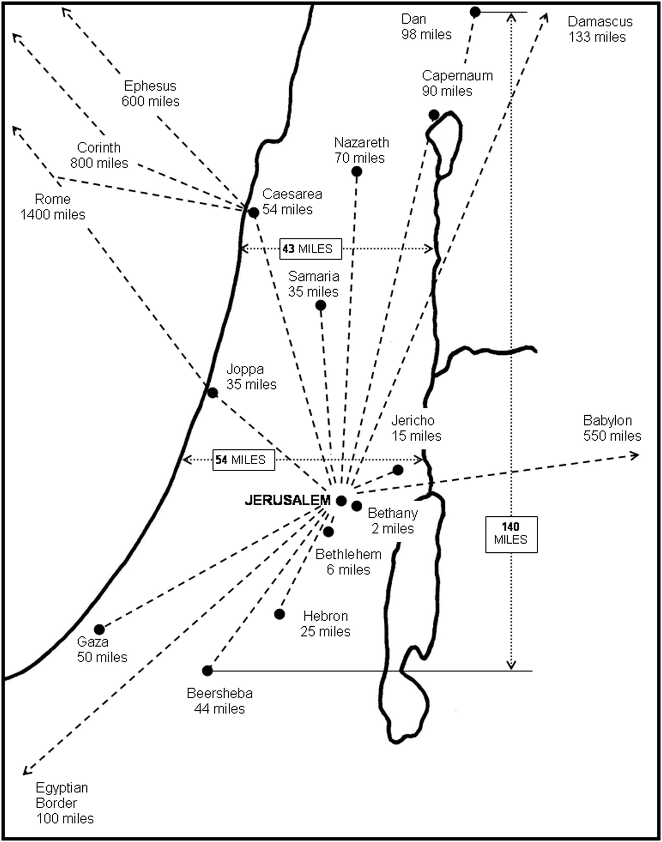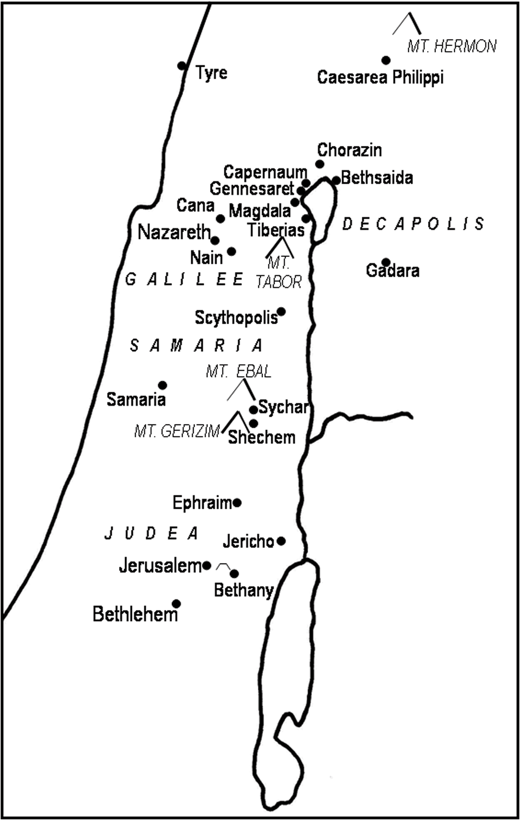
Distance from Jerusalem in miles. General location of cities and land marks in Israel.
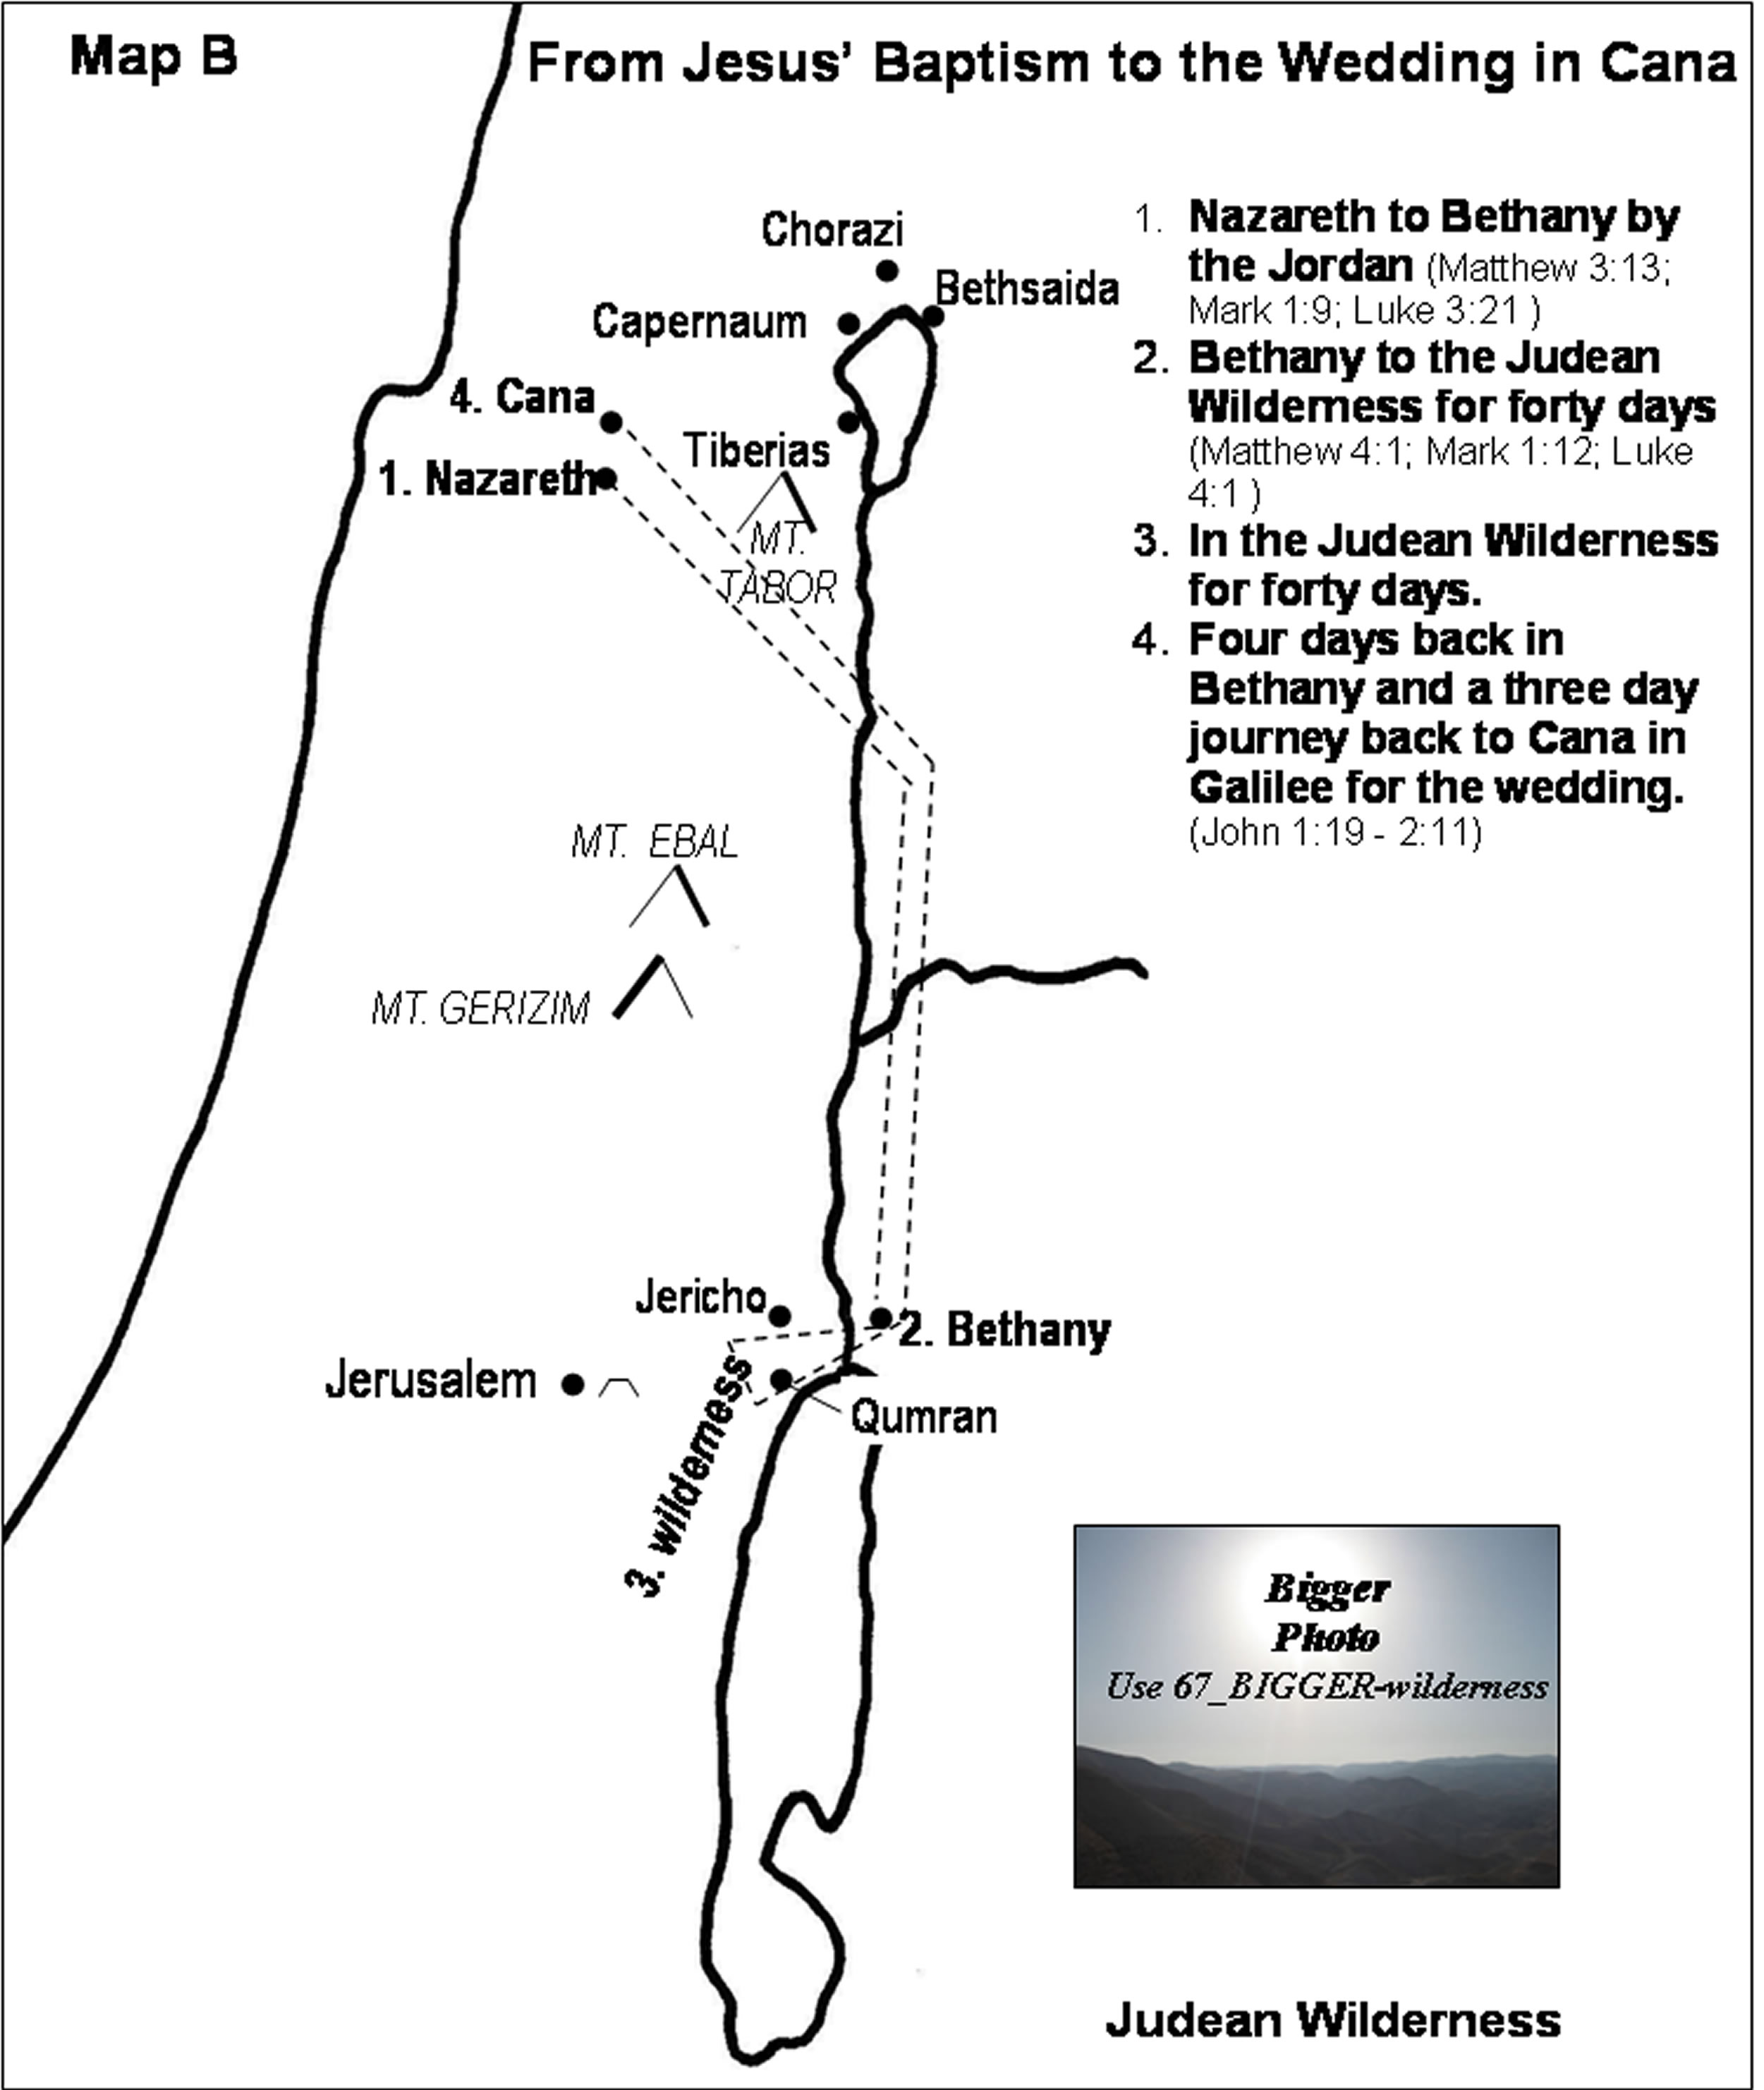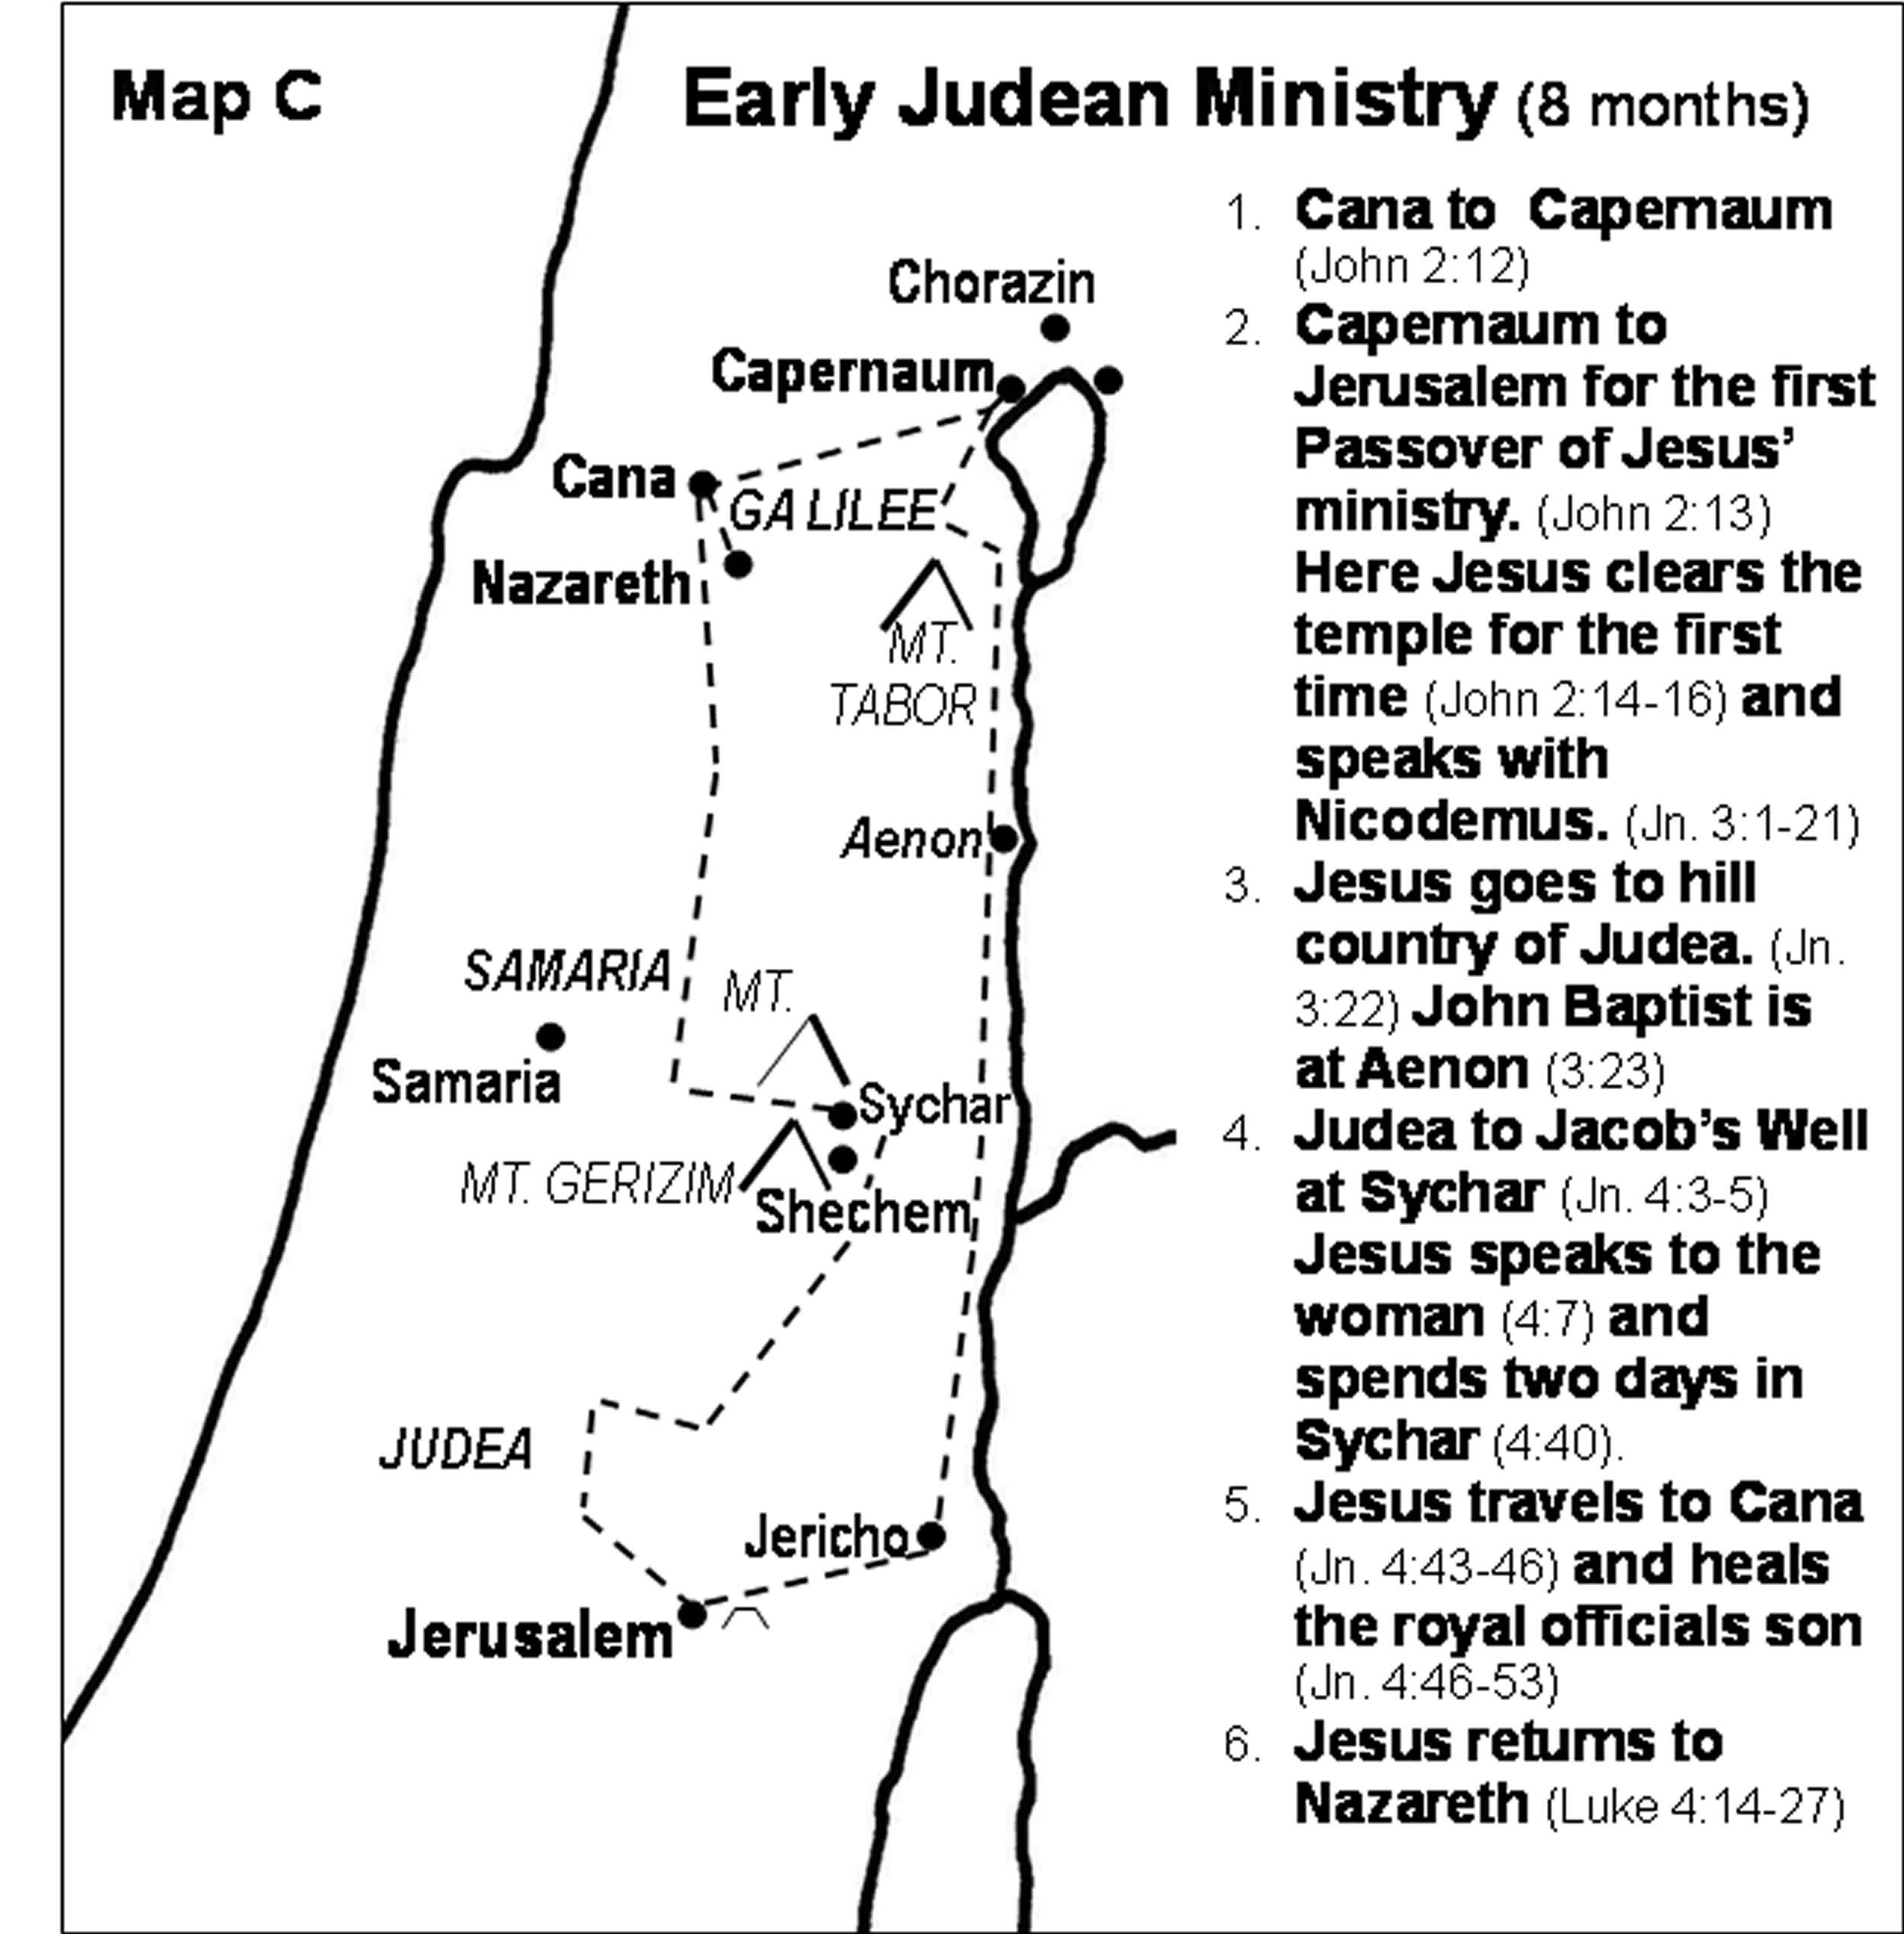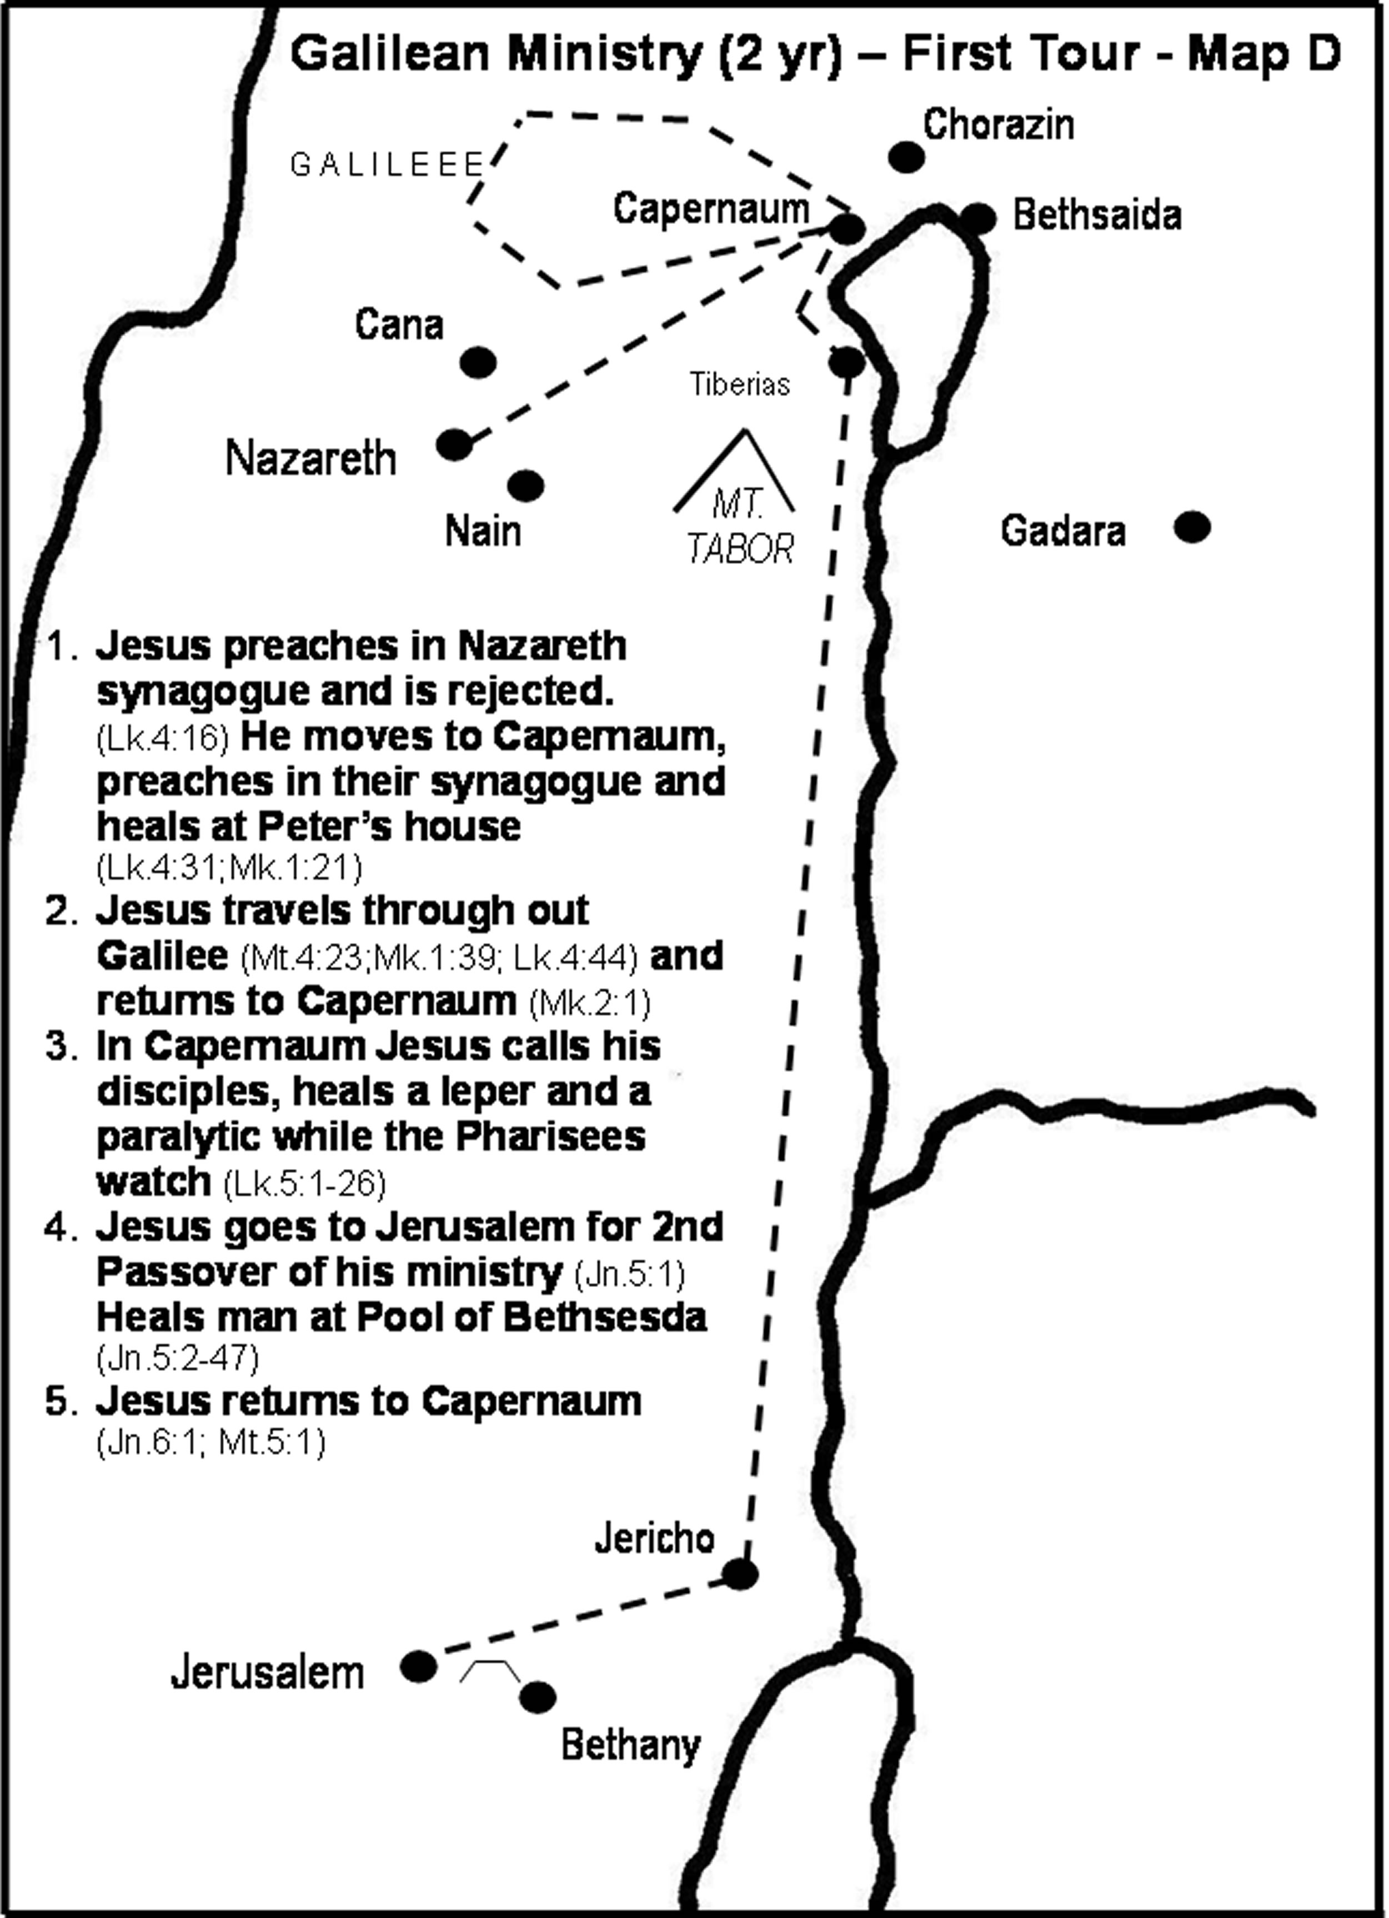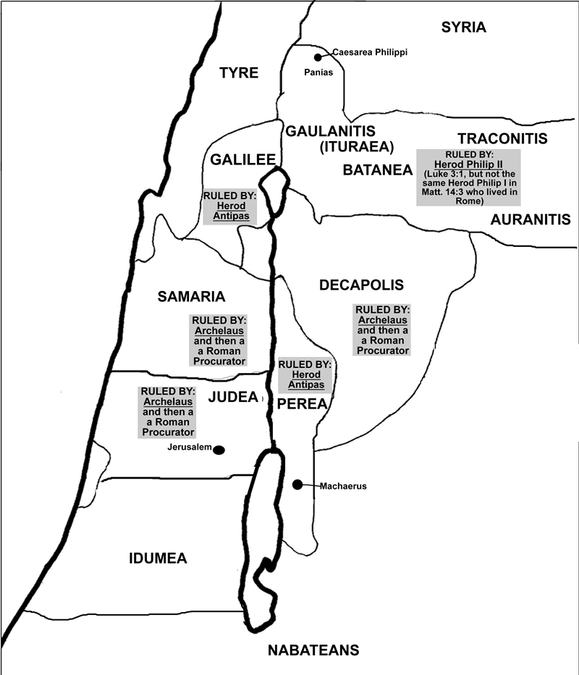

Photos of:
- Sea of Galilee - http://www.generationword.com/Israel/Sea_of_Galilee.html
- Capernaum - http://www.generationword.com/Israel/capernaum.html

Land of Galilee
Galilee is a region west of the Jordan River and the Sea of Galilee with Phoenicia (Tyre) on the west and north, Syria on the north and Samaria on the south.
Galilee is not a large area of land, but very fertile and heavily populated.
Josephus says the land was all cultivated and had no waste land.
There were about 200 cities and villages in Galilee. Josephus must exagerate when he says the smallest city in Galilee had 15,000
It is 12 miles from Cana to the Sea of Galilee (5-6 hour walk).
Largest city on Galilee was the new city of Tiberias built by Herod Antipas between 18-22 AD
The capital of Galilee was moved from Sepphoris to Tiberias. Sepphoris had a population of 50,000.
Jesus grew up 3.5 miles south of Sepphoris in Nazareth, which was also 1.5 miles east of one of Galilee's other largest cities, Japhia.
Tiberias was rumored to have been built over a cemetery so the Jews were reluctant to live in Tiberius.
The Gospels never record Jesus entering Tiberius.
The most important roads passed through Galilee. The land of Galilee was open to trade and ideas due to these routes with many races.
(Judea was in a mountainous, hill country isolated from the trade routes and off the main roads.)

City of Capernaum
Capernaum was the headquarters of Jesus ministry.
Three disciples were from here, plus Peter and Andrew moved here from Bethsaida.
Capernaum covered a quarter of a mile of sea coast.
Fishing and the industrial production of basalt implements (olive presses and grain grinders) were made here and shipped around Israel.
Capernaum sat on the International Route that ran from the Mediterranean Sea east into Transjordan and north into Syria (Damascus)
There was a custom station there because it was close to Philip's territory (Matt. 9:9).
Capernaum also was large enough for Rome to station a centurion and his troops there (Matt. 8:5-9) and an officer of the king (John 4:46)
Franciscans own it today and have excavated the city, the synagogue and built a church.

The Timeframe Between the Temptations (Matt. 4:11) and Jesus returning to Galilee after John's Arrest (Matt. 4;12)
The time between Jesus ending the temptations in 4:11 and Jesus entering Galilee in 4:12 include a time period of about 10 months:
- John 1:19-43 - Jesus returns from the wilderness and meets Andrew, John, Peter, James, Philip and Nathanael
- John 2:1-2:11 - the journey back to Galilee from the Jordan Valley where John baptized. Here is the wedding at Cana.
- John 2:12 - a visit to Capernaum.
- John 2:13 - Jesus visits Jerusalem for the first Passover of his ministry
- John 2:14-16 - Jesus clears the temple for the first time
- John 2:3:1-21 - Jesus speaks with Nicodemues
- John 3:22 - Jesus travels the Judean hill country
- John 3:23 - John the Baptist is at Aenon baptizing
- John 4:3-40 - Jesus goes into Samaria and speaks to the woman and spends two days in Sychar
- John 4:43-53 - Jesus travels to Cana and heals the royal official's son
- Luke 4:14-27 - Jesus returns to Nazareth and is rejected

Matthew 4:12-17
Matthew again uses an Old Testament passage as a prophetic reference to Jesus.

4:12
John's arrest recorded in Matthew 14:3-12. Jesus will withdraw again in Matthew 14 at John's death.
Josephus said that Herod Antipas saw John the Baptist as a source of sedition
"arrest" is a technical term for handing someone over into custody. Judas does this to Jesus but it is translated "betray."
"withdrew" indicates some kind of danger to avoid as it is used with the Magi (2:12). Herod Antipas ruled both Perea and Galilee
Jesus' preaching in Galilee was less of a direct threat than John's preaching in Perea

4:13
"left" also means "abandoned"
Luke 4:16-31 says they rejected him
"Capernaum" means "Nahum's Village"

4:14
Matthew writes "what is written in Scripture must find its fulfillment.
Matthew says the reason Jesus spend the majority of his ministry in Galilee was because Scripture said so.

4:15
"way to sea" refers to the road that ran south out of Damascus through the Capernaum area then west through Sepphoris to the Mediterranean coast. This road was called the "Way to the Sea (Mediterranean)" in 700 BC. The Romans called it "Via Maris"
"Galilee of Gentiles" was the northern part of the land of Israel and the first to be invaded by the Arameans (Syrians), Assyria, Babylonians, Greece, and the Seleucids. The Assyrians had deported many of the Jews and imported people from other lands into the land of Galilee and Samaria. Following this time the land was occupied and controlled by Gentiles. In the days of the Maccabean revolt the Jews living in the land of Galilee were evacuated into Judea. When the Hasmoneans ruled from Jerusalem the kingdom of Israel expanded and Jews again lived in Galilee and Gentiles were circumcised there in 104 BC. Since that time Judea looked down on Galilee and the Jews that lived there. Many of the Jews that lived there were not fully committed to Judaism.

4:16
"live in darkness" or "sit in darkness" indicates more than a passing moment. They are habitually in darkness.
"darkness" refers to deception, delusion, despondence. These people have no hope and no ability to alleviate their problem.
"Great light" is a reference to something more than human and beyond natural light (not an idea, nor a philosophy). Emphasis is on "great" and it refers to a divine intervention
"living" or "sitting" is repeated as is the reference to "light".
"shadow of death" is a reference to a region or an area under the control of death and darkness. This is like Ephesians 2:1-3 referring to this dark world.
"Light has dawned" the people did not produce the light. The light has dawned on its own.
The Light has been identified by Isaiah and Matthew as:
- Greater than the people and natural light
- Beyond the power and ability of the people, but instead is the source of its own dawning or coming.
This Light is divine

4:17
"From then" a new beginning, a new phase or direction of ministry
Upon arriving in Capernaum Jesus began the next phase of his ministry.
Jesus theme is:
- Repent - all people are unfit for the kingdom of God. Jesus assumes people are sinners. They must be willing to repent to receive the light that has dawned.
- Coming Kingdom - The kingdom is present in the person Jesus, but the kingdom will also come fully on the earth in the future

